PEPPER GROW TENT JOURNAL
From setup and commissioning to October 15, 2026
Spider Farmer 4 × 4 Tent • SE5000 480 W LED • GGS Environmental Control • 8 Pepper Plants

Project snapshot
This journal documents the first week of the indoor pepper grow after moving the plants into a controlled Spider Farmer tent. The goal has been to create a stable, repeatable environment, learn how the plants respond, and keep enough data and observations to improve the setup next season.

System configuration
- Spider Farmer 4 × 4 × 6.5 ft grow tent.
- SE5000 480 W LED connected to the GGS controller; dimming verified in 10 steps.
- 6-inch carbon-filter inline exhaust system; minimum fan speed verified at 25%.
- GGS-controlled oscillating clip fan for canopy air movement.
- Temperature/humidity sensor positioned around canopy height.
- Eight pepper plants in the tent; portable heater available but not required during the baseline tests.
- Controller linked to the app, with automatic exhaust control and standby options verified.

Timeline & observations

Oct. 8 - Commissioning and baseline
Initial controlled testing was completed with one pepper plant. With the SE5000 at 30% and about 30 inches above the canopy, exhaust at the 25% minimum, clip fan on low and oscillating, heater off, and tent closed, the environment stabilized around 22.4°C, 45.5% RH and 1.48 kPa VPD. This established a useful reference point before loading the tent.

Oct. 9 - Eight peppers moved into the tent
The grow became a full-canopy test with eight pepper plants. Exhaust automatic mode and standby behavior were configured; a 40% running speed was discussed while the 25% minimum remained enforced. The focus shifted from equipment commissioning to plant response.

Oct. 10-11 - First continuous data
The first exported environmental reports showed the tent cycling normally. The plants appeared healthy and visibly benefited from the more stable light and environment. Rather than constantly changing settings, the strategy became to collect daily data and look for trends.

Oct. 12-14 - Stable environment
Repeated exports showed a generally stable tent. Temperature, humidity and VPD moved with the light/dark cycle but remained in a practical range for established peppers. No evidence from the environmental data suggested a persistently hot or excessively humid tent.

Oct. 15 - Leaf edema-like bumps observed
Raised blister-like bumps were noticed on leaves of some, but not all, pepper plants. The appearance is strongly consistent with physiological edema: roots taking up water faster than leaves can transpire it. A small watering had occurred shortly before the bumps were noticed. Because the shared air environment is stable and only some plants are affected, individual root-zone moisture is a leading suspect. Response: pause watering until pots dry appreciably, maintain gentle air movement and normal exhaust, do not use a heat mat, and judge recovery by smooth new growth rather than expecting existing affected leaves to become smooth.

Environmental data: Oct. 9-15
The latest export contains 1,947 readings from October 09 through October 15, 2026. The overall numbers support the observation that the tent has been stable rather than chronically humid.
Metric | Average | Minimum | Maximum
Temperature | 20.4°C | 17.5°C | 23.2°C
Relative humidity | 53.6% | 45.4% | 62.3%
VPD | 1.1 kPa | 0.8 kPa | 1.5 kPa
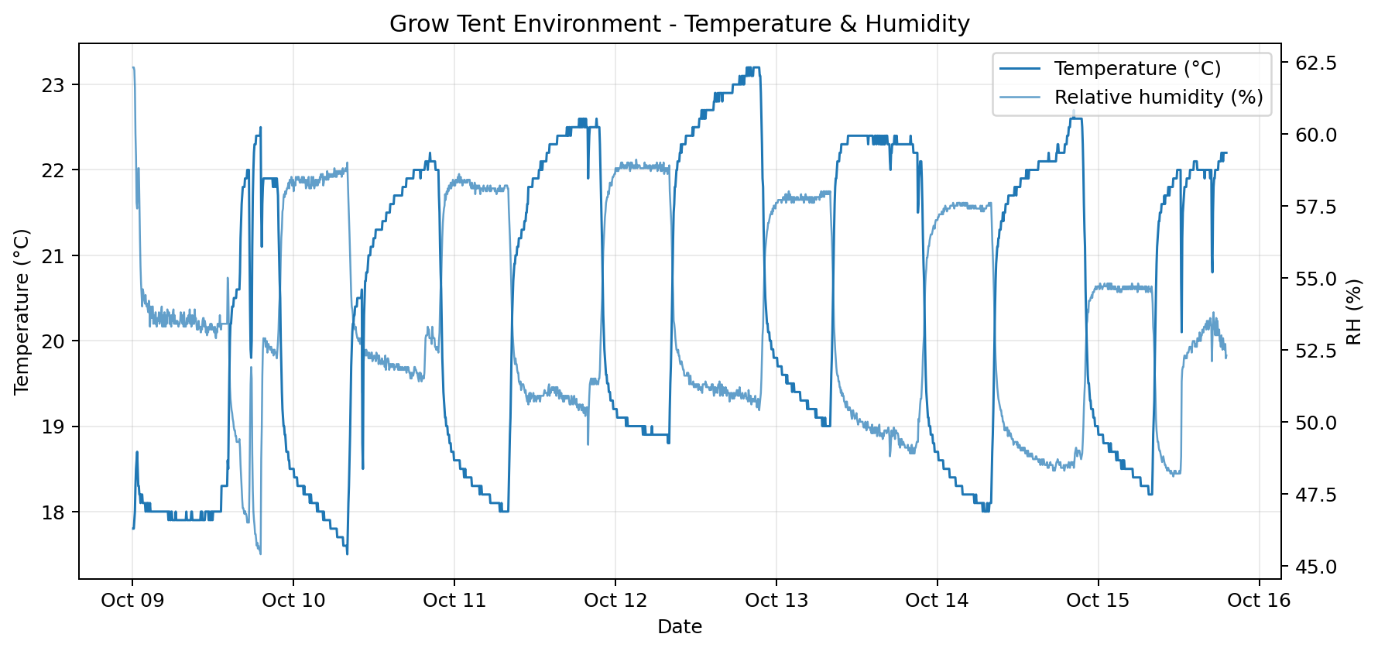
Figure 1. Temperature and relative humidity from the latest controller export.
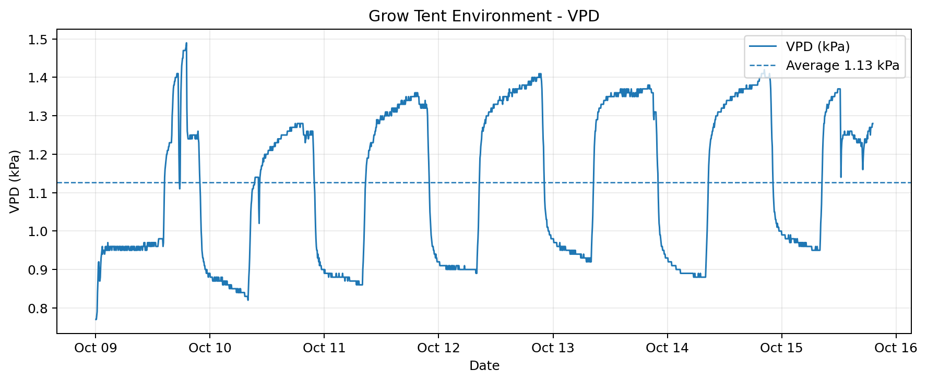
Figure 2. VPD over the same period. Short lower-VPD periods are more relevant to edema risk when the root zone is wet than the overall average alone.

Daily averages
Date | Temp avg | Temp min | Temp max | RH avg | VPD avg | VPD min
Oct 09 | 19.2°C | 17.8°C | 22.5°C | 53.0% | 1.05 | 0.77
Oct 10 | 20.0°C | 17.5°C | 22.2°C | 54.9% | 1.07 | 0.82
Oct 11 | 20.5°C | 18.0°C | 22.6°C | 54.1% | 1.12 | 0.86
Oct 12 | 21.2°C | 18.8°C | 23.2°C | 54.4% | 1.16 | 0.89
Oct 13 | 21.0°C | 18.7°C | 22.4°C | 53.2% | 1.17 | 0.92
Oct 14 | 20.5°C | 18.0°C | 22.7°C | 52.4% | 1.16 | 0.88
Oct 15 | 20.4°C | 18.2°C | 22.2°C | 52.7% | 1.14 | 0.95

What we learned
- The tent itself is performing well. Stability has improved substantially compared with an uncontrolled indoor environment.
- Plant problems should not automatically trigger controller changes. Root-zone moisture can differ from pot to pot even when every plant shares the same air.
- Edema is a useful reminder to coordinate watering with transpiration. Avoid keeping established pepper roots continuously wet, particularly before the cooler/darker part of the cycle.
- Existing edema-damaged leaves may remain textured. The key recovery indicator is healthy, smooth new growth.
- Changing one variable at a time makes the data much more valuable. For now, the environmental settings stay essentially unchanged while watering frequency is adjusted.

Current plan - Oct. 15
- Allow each pot to dry appreciably before watering again; use both soil feel and pot weight rather than a fixed calendar.
- Keep gentle circulation across the canopy and normal automatic exhaust operation.
- Do not place the established pepper pots on a heat mat while the root zone is wet.
- Leave affected leaves attached unless they become badly damaged.
- Watch the newest leaves over the next several days. Smooth new growth with no increase in blistering will indicate that the correction is working.
- Continue exporting controller data so environmental trends can be compared with plant observations.

Closing note
The first week has already produced something more valuable than a perfectly uneventful grow: a documented baseline and a real plant response that can be tied back to environmental data and watering practices. The tent is doing its job. The next step is simply to let the root zone rebalance, keep watching the new growth, and continue building the journal.

